  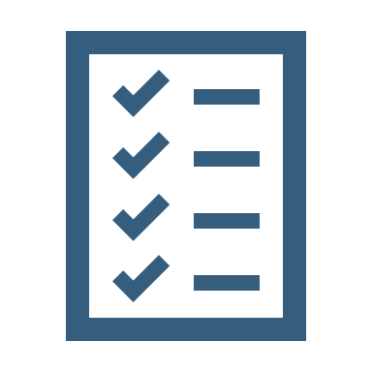  Volunteer  Application  Applicant’s Name | Date Click or tap to enter a date.  Address Click or tap here to enter text.  Phone Click or tap here to enter text.  E-mail Click or tap here to enter text.  Areas of Interest  Processing of Collections Click or tap here to enter text.  Scanning Click or tap here to enter text.  Transcription Click or tap here to enter text.  Data Entry/Indexing Click or tap here to enter text.  Conservation/Preservation Click or tap here to enter text.  Programming/Outreach Click or tap here to enter text.  Communications/Writing Click or tap here to enter text.  Outreach/Media/Publicity Click or tap here to enter text.  Digital preservation/processing Click or tap here to enter text.  Oral history interviews Click or tap here to enter text.  Weekly Availability  Morning  M ☐ T ☐ W ☐ Th ☐ F ☐  Afternoon  M ☐ T ☐ W ☐ Th ☐ F ☐  Please list skills, qualifications, and areas of interest below:  Thank you for considering the State Archives as a volunteer opportunity. Please return the completed form to Christine Botta at christine.botta@ncdcr.gov

